**INDUSTRY VERTICAL**

Team JAC ASS has chosen the **Healthcare** Industry Vertical.

**CATEGORY**

Team JAC ASS has chosen the **Artificial Intelligence (A.I)** Category.

**OBJECTIVE**

A problem in the healthcare industry is elderly people face a multitude of health issues. The tracking and monitoring of health issues/symptoms, as well as the use of healthcare technology is difficult for the elderly population to handle. Our objective is to utilize AI technology in a multitude of ways to aid the elderly population in dealing with the management of their health, as well as helping them to understand how to use such technology.

**PROJECT CONTEXT**

With the world population ageing at a rapid rate and medical technology innovations right behind them, it is the seniors that would benefit most from what it has to offer. Unlike the younger generations, seniors were not born into technology and have proven to show lower rates of technology adaptation. This could be due to the fact many technology applications are designed with the ability to see, hear and read; seniors are not at their prime level due to health conditions. They also experience decreased cognitive ability, making it harder for them to keep up with constant updates, releases, and technology.

Assistance, that many of us can relate to, is needed for them to comprehend technology but even with guidance they are left feeling overwhelmed. When explaining how to use an interface, we can accidentally skip certain steps because many of us unconsciously know where certain elements are on an interface (e.g., navigation bar or search) and are quick to assume seniors know too. Teaching an individual who has never interacted with technology is like teaching someone a new language; it takes time, practice, and patience. The lack of this knowledge and understanding stops seniors from embracing technology and as it continues to grow, feelings of alienation can evolve. Some seniors already suffer from mental health issues from loss of loved ones and loneliness.

It is important to find solutions to help bridge this gap as technology can greatly improve the lifestyle, maintenance, and health of seniors. Seniors rely on prescribed medications to maintain their health and increase longevity. The American Heart Association says, "Poor medication adherence takes the lives of 125,000 Americans annually, and costs the healthcare system nearly $300 billion a year in additional doctor visits, emergency department visits, and hospitalizations." With forgetfulness as a symptom of old age, medical adherence can be an issue among seniors; something technology can help with. Implementing artificial intelligence and other features can drastically improve the healthcare system.  Although, it is important to keep in mind that like any other electronic they can malfunction. The likely hood of a technology in its late design stage will show minimal errors but can reveal itself after user testing. When storing important medical information, developers need to ensure low rates of mistakes. Some individuals do not trust technology with valuable information; companies need to ensure privacy and security guidelines are met.

A survey by ITOK.net has shown that 91% of seniors would use medical technology if their doctors recommend it. In order for seniors to make that commitment, they would have to understand what they’re doing. The first and foremost problem is how to clearly communicate important information to a senior with little to no guidance.

**PRECEDENT RESEARCH SUMMARY**

**Precedent 1: Mabu**

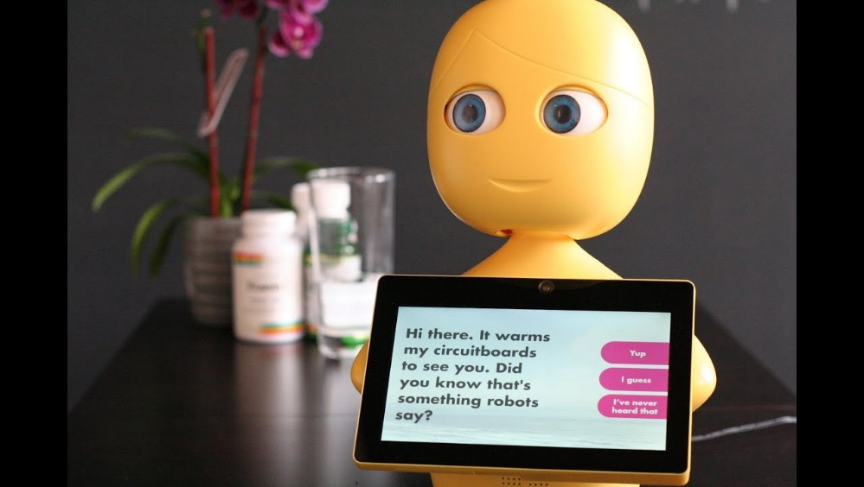

Maker: Catalia Health Inc

Year : 2015

Technology\used : Cloud, AI , Psychology Behavioural models, Best Medical Practices

Mabu is a healthcare assistant developed by Catalina Inc. It’s specifically catered to help elderly people manage their health and wellbeing, with the capability to:

* Track health and treatment progress and reminds user to take medication
* Helps answer patient’s concerns and queries regarding medication. It can accomplish this through it’s integration with medical databases, to retrieve info from as required. It also tracks health and advises where medical attention is needed.
* Mabu engages with the user depending on their personality.
* Users can set health goals and receive tips on stress relaxation and physical exercises.

**Why was this chosen as a Precedent:** For an AI assistance to be truly useful in taking care of an elderly person’s health, the features that Mabu possesses would be necessary to integrate. Specifically, the features that would allowing the user to look up their medication that a healthcare professional has prescribed to them, get reminders to take their medication, and get help with sticking to exercises and a personal care plan that the user has gone over with a professional.

**Precedent 2: Dinsow Mini**

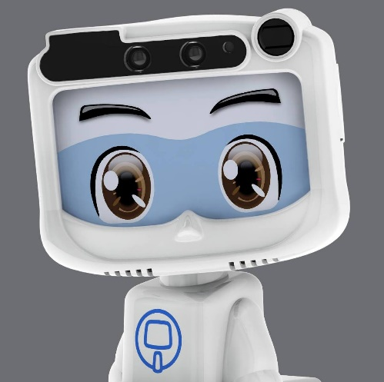

Maker: CT ASIA ROBOTICS

Year: 2015

Technology: AI, Robotics, sensors, voice recognition, voice command , face recognition

Dinsow is designed to assist older adults in multiple areas of their lives. It has both medical and social capabilities, such as:

* Keeping track of an older person’s pills and help with health care related issues.
* Setting up video chatting with family for people who may have a hard time doing it themselves.
* A karaoke feature meant to amuse and entertain its owners.
* Engages users with brain exercises
* Alerts family in case of urgency
* Detects unusual facial expressions and behavior

**Why was this chosen as a precedent:** A potential AI companion should have this friendly and sociable look, being able to offer companionship, communication and engagement through games or exercises, while also helping the elderly with basic medical check-ins. This ensures the mental wellbeing of the user is taken care of, while also aiding in the prevention of certain cognitive declines that can happen as a result of old age.

**Precedent 3: Fitbit**

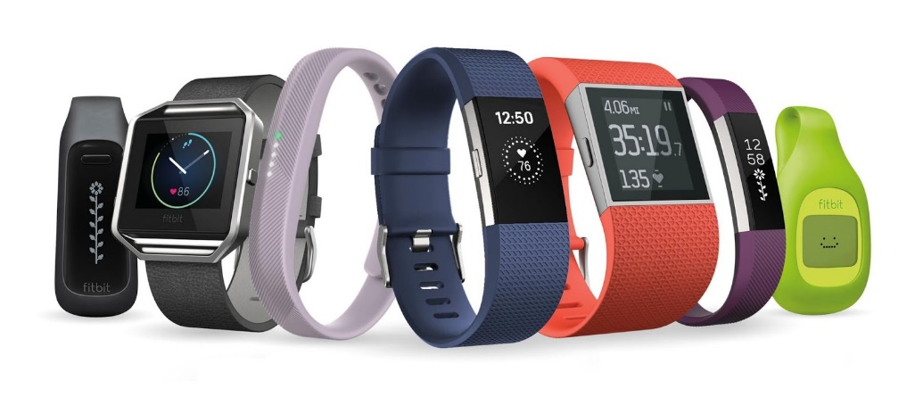Year 2007

Makers: James Park and Eric Friedman

Manufacturers: Fitbit inc.

Technology: Sensors, Accelerometers

The FitBit is a wireless device that uses an internal motion detector to track various health statistics from the wearer such as movement, sleep, calorie burn, etc. It allows people to be more aware of their health and live a more active lifestyle. It eventually released a phone app to couple with the product which helped users further their fitness goal even more so by setting in app goals, gaining badges, seeing a visual representation of their metrics and more.

**Why was this chosen as a precedent:** The health monitoring technology of Fitbit can be used in our product to provide for accurate medical assistance for the AI companion. If the AI can analyze the wearer’s vitals, it can easily provide medical advice. It can also be able to alert emergency services if they are in critical condition.

**Precedent 4: Echo Dot (3rd gen) Kids Edition**

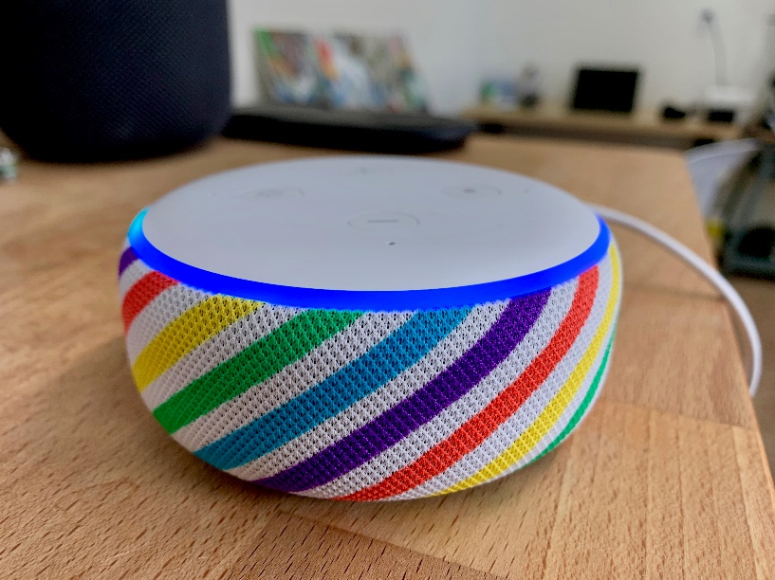

Year: 2020

Makers/Manufacutrers: Amazon

Technology: Smart Home Device, AI, voice recognition

The Echo Dot is an AI assistant that is specifically geared towards kid-friendly interaction. It has a bright and colourful look to appeal to younger audiences, along with speech patterns that are more friendly and have easier terminology that allow children to understand the AI and have a desire to engage with it. Alexa (the name of the AI assistant) can perform tasks such as reading stories, calling friends/family members, play songs (with explicit lyrics flitered out to be acceptable for young audiences), and much more.

**Why this was chosen as a precedent:** The idea of the AI’s speech patterns, language, descriptions and tone of voice being targeted to a specific audience is something that can be implemented for this AI assistant as well. Making sure to describe instructions in extra detail, using a mature and clear tone of voice can be very helpful to the elderly in being willing to integrate an AI assistant in their daily life.

**CONSIDERATIONS**

1. AI is still fairly new and currently going through multiple development stages.
2. The concerns with AI technology having to do with privacy. AI learns from the world around it (Alexa) so when it listens, it collects data.
3. AI in the social world is considered revolutionary and will eventually replace most.
4. AI is most popular in voice assistants.
5. Main legal issues which are heavily focused on Data Privacy, and Jobs being taken by AI
6. Because AI is fairly new, errors and results can be skewed quite frequently.
7. Constant update to networks, health records and algorithms will concern users whether they can rely on AI based technology.
8. Health Leaks and Viruses / Malware are a huge concern when related to technology in general. Bigger concerns are concentrated towards AI and NFC (Near Frequency Communication).
9. Elderly people will not adapt to technology as fast as millennials. This is a huge concern when leaving them alone with technology.
10. When considering elderly people and technology it may be required to have trained employees and nurses that understand how to use the technology.
11. Communication with family is important, there usually the first to know of any emergency or accident
12. Seniors can lack visual, audio, mobility, or stamina.

**TARGET AUDIENCE**

The target audiences are seniors who have more than one health issue and carefully manage chronic conditions to stay healthy.  They need to manage their health on a daily basis, but they are having trouble with doing this.

**Gender:** Regardless of gender, all seniors need to monitor their health.  However, depending on gender conditions and diseases that need to be tracked might be different.

**Age:** Above 65

**Location**: Suburban areas, retirement homes

**Occupation:** Mostly retired.  Sometimes, they take care of their grandchildren, and spend time with friends and family.

**Marital and child status**: It is various.  There are cases that they did not get married, and in some cases, their spouses are sick or dead.  Also, even though they have children, they might live far from their parents, so they cannot help their parents when health issues occur. In hence, the degree of assistance may vary depending on their status.

**Day-to-Day / Hobbies:** They usually enjoy playing tennis and try to take a walk every day for health.  Also, they like to hang out with friends every morning at a coffee shop.  However, they have concerns about being infected by Covid-19, so it makes them reluctant to take a walk every day, and currently it is hard to meet their friends frequently.

**Important Issue:** Health is the most important issue for them.  Currently, Covid-19 is the biggest concern as there are many elderly people who died from Coronavirus.  Also, they are afraid to worry their children.  Even though they have a small problem in health, they tend not to tell it to their children.